Prof. Gabriel Kaufmann Research
Research Interests
Suicidal, phage-excluding tRNases PrrC and RloC
Loss of a single tRNA species suffices to block translation, arrest growth and eventually cause cell death (1). Microbial organisms accomplish this feat using nucleases that target tRNA's Achilles heel. These anticodon nucleases (ACNases)exclude phage, kill competing cells and may provide other, yet unknown advantages.
We focus on the suicidal, phage-excluding ACNase PrrC (1, 2) and its less familiar paralog RloC (3). PrrC is silenced in uninfected E. coli by the associated type I DNA restriction nuclease EcoprrI and unleashed during phage T4 infection by the T4-encoded anti-DNA restriction factor Stp (Fig. 1).
The resulting incision of tRNA^{Lys} could block phage protein synthesis and contain the infection but T4 tRNA repair enzymes counteract the damage. Currently we study how EcoprrI, Stp and two different nucleotides recognized by PrrC's ABC ATPase-like N-domain regulate the ACNase.
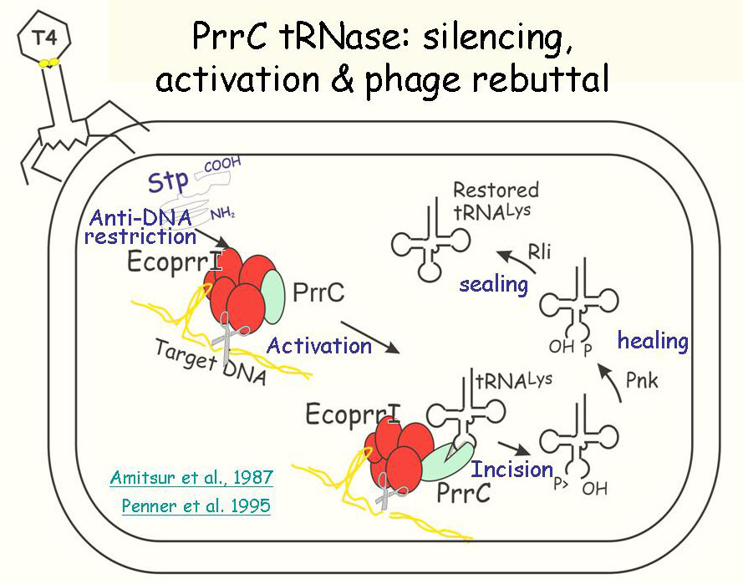
Fig. 1. The anticodon nuclease PrrC: silencing, activation and phage rebuttal. PrrC (green oval) is kept inactive before infection by the associated type I DNA restriction-modification enzyme EcoprrI (red ensemble). During phage T4 infection the phage-encoded peptide Stp, an intended inhibitor of EcoprrI's DNA restriction activates the latent PrrC tRNase. The resultant incision of tRNA^{Lys} is counteracted by T4-encoded 3'-phosphatase/5'-polynucleotide kinase (Pnk) and RNA ligase 1 (Rli).
RloC seems to be a more sophisticated version of PrrC, judged from two of its distinct properties. First, RloC excises its substrate's wobble nucleotide, a lesion likely to impede phage reversal and render RloC a more potent antiviral device than PrrC (3).
Second, RloC's complex regulatory domain (Fig. 2) resembles Rad50 and related DNA repair proteins endowed with DNA bridging activity (3, 6). RloC's DNA bridging activity (Fig. 3) impacts its ACNase function in a significant way (3). These facts, taken with the transient inactivation of type I DNA restriction enzymes following DNA damage (7), underlie a model where RloC wards off phage escaping DNA restriction during recovery from DNA damage (3). This model is currently tested.
The above examples of RNA repair and, possibly, repair avoidance could be considered isolated cases where lack of a suitable DNA template precludes replenishment of the damaged RNA by transcription. Nonetheless, various types of cellular RNA repair have popped up recently: RNA polymerases proofread their transcripts (8), an RNA methylase removes toxic methyl groups (9) and a cellular repair-modification complex prevents re-cleavage of the RNA it mends (10). These findings hint that RNA repair figures in cell biology more than previously appreciated.

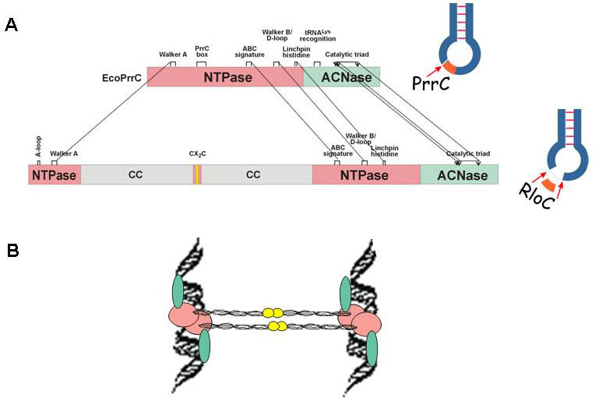
Fig. 2. A. Domain alignment of PrrC and RloC (3-5). ATPase and ACNase domains are respective pink or green rectangles; RloC's predicted coiled coil (CC) grey, the interrupting gap in pink and the zinc-hook motif in yellow. Dashed lines connect shared motifs. B. Cartoon of RloC's expected mode of DNA bridging [adapted from Rad50's (6)]. The CC/ZH protrusions bridge DNA molecules tethered to ATPase head domains (pink ovals) by coordinating zinc ions at the ZH dimerization interfaces (yellow circles)
Fig. 3. AFM imaging of RloC DNA bridging activity. AFM image of plasmid pUC19 (A) and its complex with RloC-E696A (B). The molecules were deposited on mica and visualized by AFM. RloC is seen as bright spots that bridge distant regions of the DNA (in collaboration with D. Zikich and A. Kotlyar, TAU Department of Biochemistry).
References
1. G. Kaufmann, Trends Biochem. Sci. 25, 70 (2000).
2. S. Blanga-Kanfi, M. Amitsur, A. Azem, G. Kaufmann, Nucleic Acids Res. 34, 3209 (2006).
3. E. Davidov, G. Kaufmann, Mol. Microbiol. 69, 1560 (2008).
4. H. Masaki, T. Ogawa, Biochimie 84, 433 (2002).
5. J. Lu, B. Huang, A. Esberg, M. J. Johansson, A. S. Bystrom, RNA. 11, 1648 (2005).
6. K. P. Hopfner et al., Nature 418, 562 (2002).
7. G. W. Blakely, N. E. Murray, Mol. Microbiol. 60, 883 (2006).
8. D. Wang et al., Science 324, 1203 (2009).
9. P. A. Aas et al., Nature 421, 859 (2003).
10. C. M. Chan, C. Zhou, R. H. Huang, Science 326, 247 (2009).

