Itai Benhar Research

Protein-protein interactions are the foundation of many biological processes. As we enter the post-Genomic era, the elucidation of such interactions becomes central to biological research. My research is focused on studying protein-protein interactions by developing and applying novel protein biotechnology tools. In particular, I am interested in the mechanisms of antibody-antigen recognition and have concentrated on the following research goals:
a) Elucidation of antibody-antigen interactions at the mechanistic and atomic levels.
b) Manipulation of antibody-folding, towards enhancement of stability and solubility.
c) Application of antibodies and peptide-aptamers as modifiers of biological processes, such as enzymatic activities.
d) Using recombinant antibodies as targeting moieties of drug-delivery platforms such as immuntoxins and targeted drug-carrying phage nanoparticles
Antibody Engineering
With over 10 billion dollars in annual sales (2007 figures), antibodies and antibody-related products currently dominate the market of protein pharmaceutics. As a result, antibody engineering (a 50 billion dollar industry, 2007 figures) is a leading biotechnological field (Figure 1). Antibody engineering is based on thorugh understanding of antibodies structure-function and the ability to manipulate those at will. The Fv or Fab parts (Figure 2) are manipulated for modifying binding affinity and specificity, while the Fc part is manipulated with the porpose of manipulating effector-functions of the antibody. In addition, antibody engineering, which was born with monoclonal antibodies in 1975, is currently applied to make (therapeutic) antibodies more human in nature (Figure 3). Antibody engineering is also about making various forms of recombinant antibody fragments, each with its unique properties and applicatios (Figure 4).
Figure 1
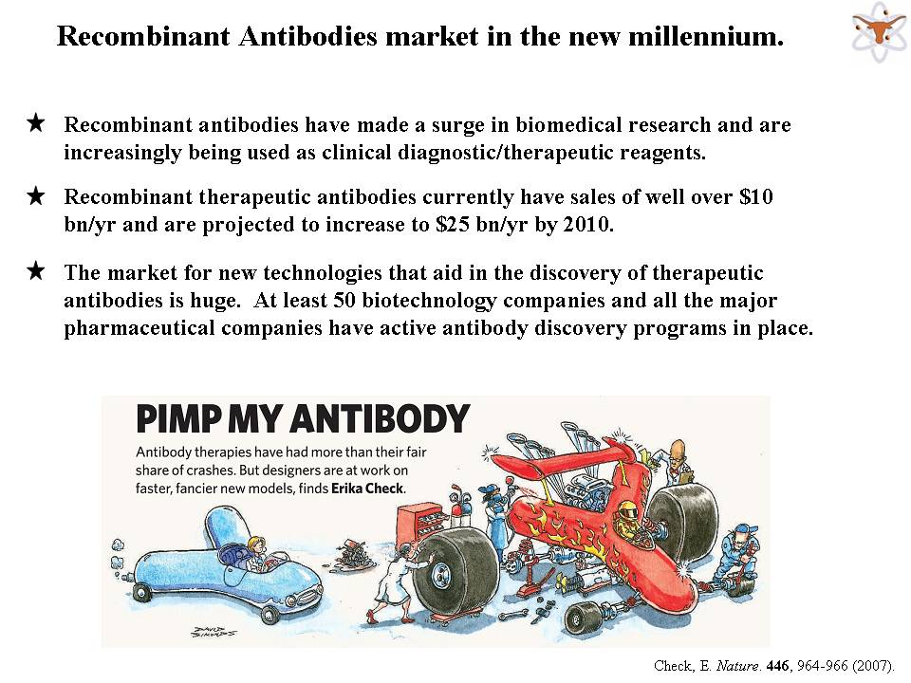
Figure 2
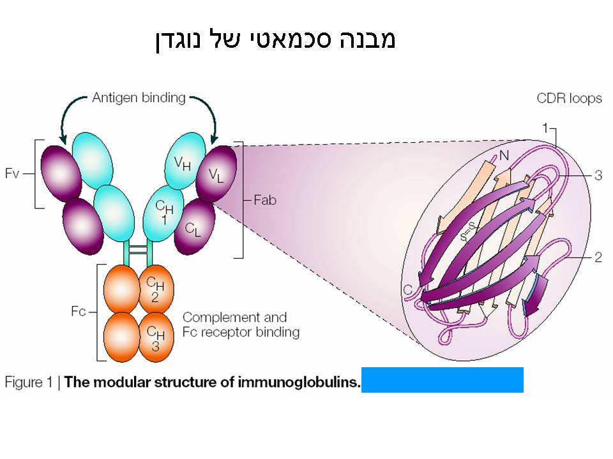
Figure 3
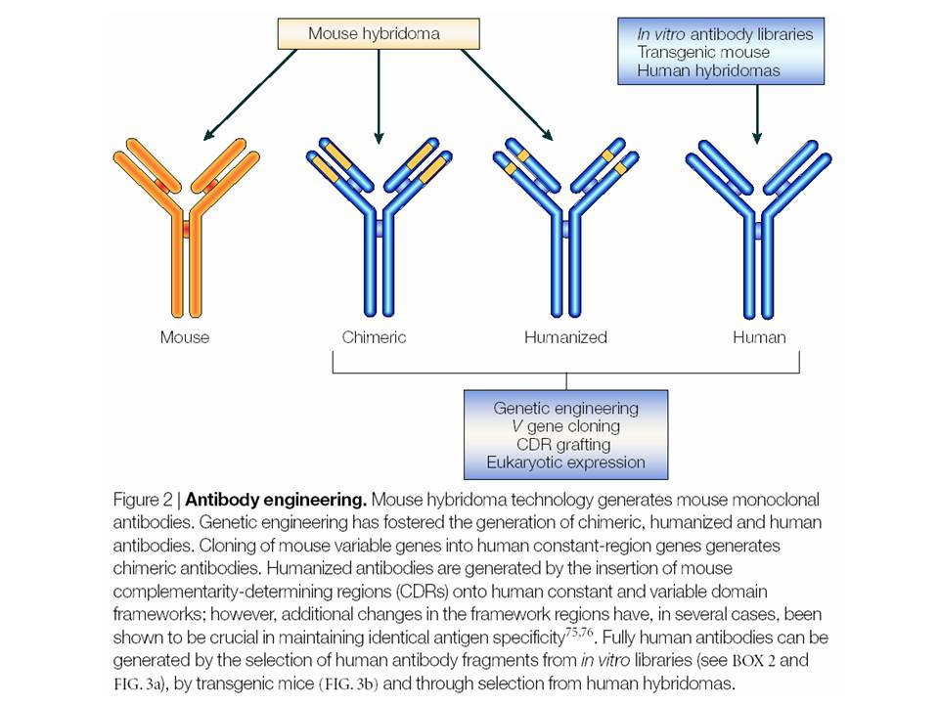
Figure 4
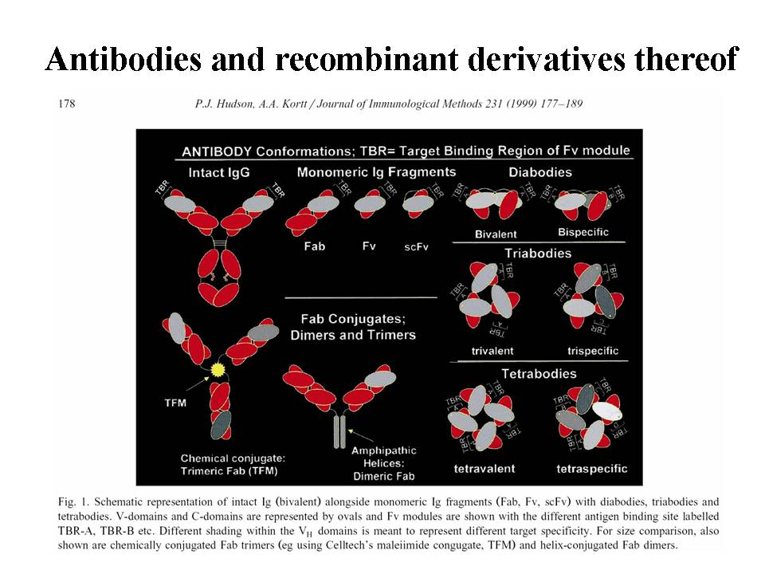
Display technologies are a central part of antibody engineering as antibody discovery-isolation-optimization tools (Benhar 2001, Benhar 2007). Display technology is based on generating a large repertoire of potential binders (an antibody library) which contains million to billions of individual clones. Selective pressure, usually in the form of affinity selection is than applied to pan out the clones with desired specificities (Figure 5).
Figure 5
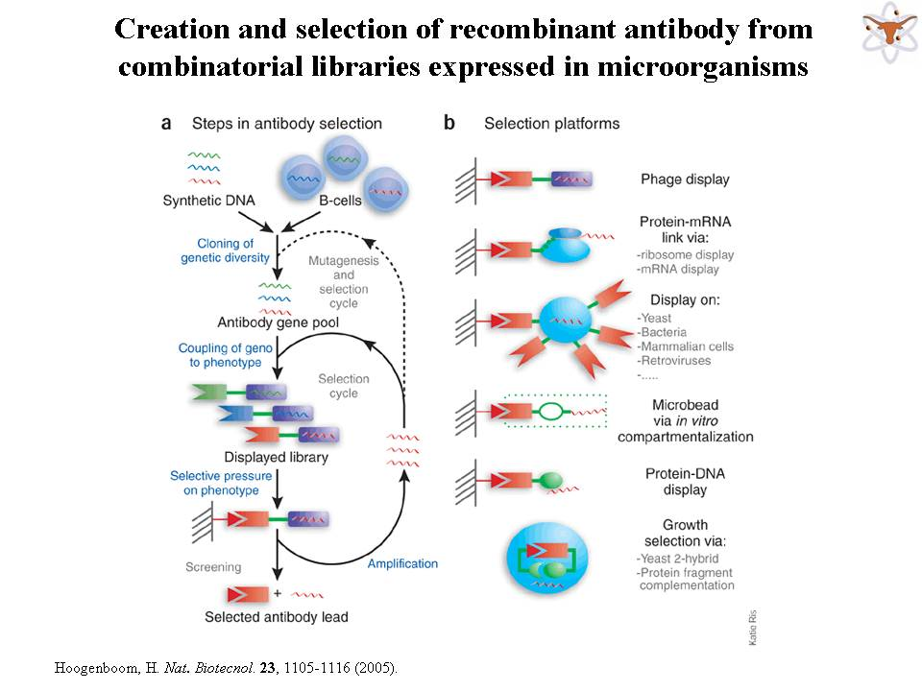
With regard to antibody technology, we had recently introduced the concept of “antibody arrays for functional genomics”. We developed a novel approach for high-throughput screening of recombinant antibodies, based on their immobilization on solid cellulose-based supports. We constructed a large human synthetic single-chain Fv antibody library where in vivo formed complementarity determining regions were shuffled combinatorially onto germline-derived human variable region frameworks. The arraying of library-derived scFvs was facilitated by our unique display/expression system, where scFvs are expressed as fusion proteins with a cellulose-binding domain (CBD). Escherichia coli cells expressing library-derived scFv-CBDs are grown on a porous master filter on top of a second cellulose-based filter that captures the antibodies secreted by the bacteria. The cellulose filter is probed with labeled antigen allowing the identification of specific binders and the recovery of the original bacterial clones from the master filter (Figure 6). These filters may be simultaneously probed with a number of antigens allowing the isolation of a number of binding specificities and the validation of specificity of binders (Figure 7). We screened our library against a number of cancer-related peptides, proteins, and peptide–protein complexes and yielded antibody fragments exhibiting dissociation constants in the low nanomolar range (Azriel-Rosenfeld et al., 2004). Our new antibody phage library, called: the “Ronit 1 library” became a valuable source of antibodies to many different targets, and to play a vital role in facilitating high-throughput target discovery and validation in the area of functional cancer genomics. That potential was recently demonstrated when antibodies we isolated from the library were used to characterize a new HLA-A*0201-restrected CTL epitope of PAP, a putative tumor associated antigen relevant to prostate cancer. This epitope, designated as PAP-3 (ILLWQPIPV), induced CTLs capable to lyse in-vitro HLA-A*0201 and PAP-positive tumor cells. We isolated from the “Ronit 1 library” recombinant single-chain Fv antibodies against HLA-A*0201/PAP-3 complexes and confirmed by confocal microscopy the presentation of PAP-3 by tumor cells in the context of HLA-A*0201 molecules (Machlenkin et al., 2007) (Figure 8).
Figure 6
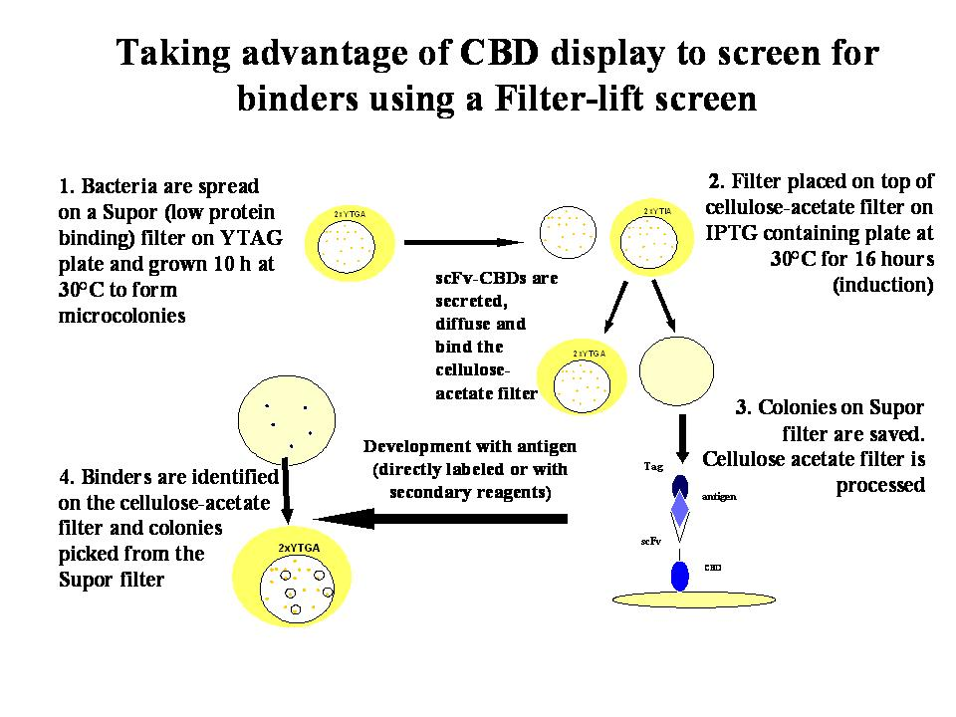
Figure 7
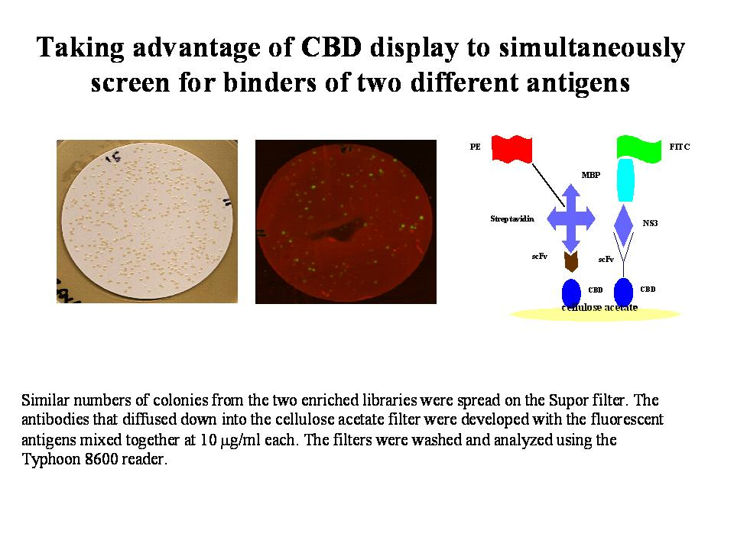
Figure 8
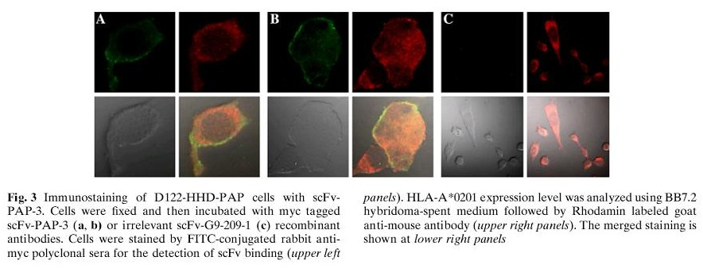
Further, we recently demonstrated the potential of our antibodies to be incorporated into antibody chips. In that study we described a simple yet efficient strategy for the production of non-DNA microarrays, based on the tenacious affinity of a carbohydrate-binding module (CBM, formally CBD) for its three-dimensional substrate, i.e., cellulose. Various microarray formats were described, e.g., conventional and single chain antibody and peptide microarray for serodiagnosis of HIV patients (Ofir et al., 2005) (Figure 9).
Figure 9
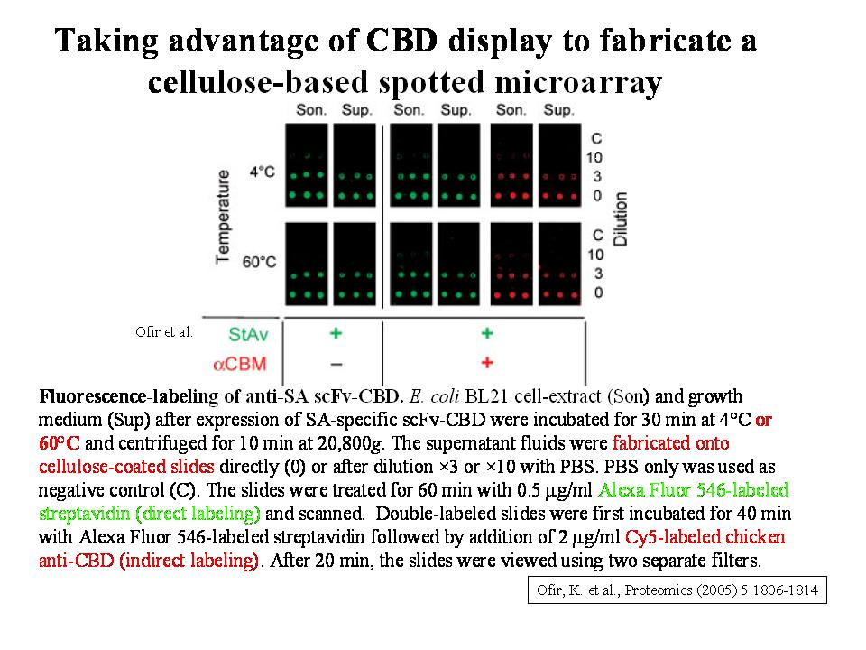
Targeted immunotherapy
We applied recombinant antibody technology to clone and humanize the monoclonal antibody H23. The tumor-associated antigen MUC1 is a cell surface mucin that is expressed on the apical surface of most glandular epithelial cells, including the ducts of the breast, ovary, pancrease, lung and colon. During malignancy, epithelial tissues regularly display elevated levels of MUC1 in a non-polar fashion and in an underglycosylated form, exposing cryptic peptide and carbohydrate epitopes. As such, MUC1 is regarded a potential target for immunotherapeutical intervention. Murine monoclonal H23 antibody specifically recognizes a MUC1 epitope on the surface of human breast cancer cells. We described the cloning of the variable domains of H23 and their expression in (Escherichia coli) E. coli as maltose-binding protein-scFv (MBP-scFv) fusions. We humanized H23 and evaluated the binding properties of the murine and the humanized recombinant forms, which were similar in affinity and specificity, but lower in apparent affinity in comparison to the original monoclonal IgG. We mapped the epitope of humanized H23 by affinity-selecting a phage-displayed random peptide library on humanized H23 scFv-displaying bacteria. Our results show that humanized H23 binds an epitope corresponding to the MUC1 tandem repeat and an additional epitope not related to MUC1. These epitopes are competitive, bound with similar affinities and are recognized by the original murine H23 monoclonal antibody as well (Mazor et al., 2005) (Figure 10). In more recent work, we generated an expression system for whole IgG antibodies in transfected mammalian cells (Figure 11) and used it to prepare IgG mouse/human chimeric derivative that are being evaluated for their potential to deliver a cytotoxic payload to cancer cells.
Figure 10
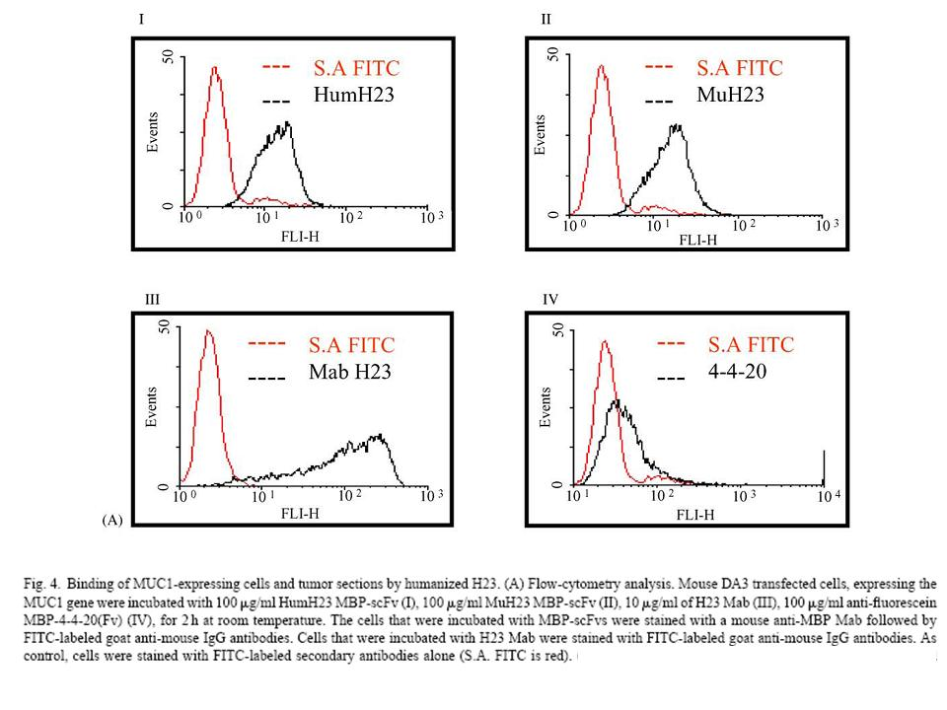
Figure 11
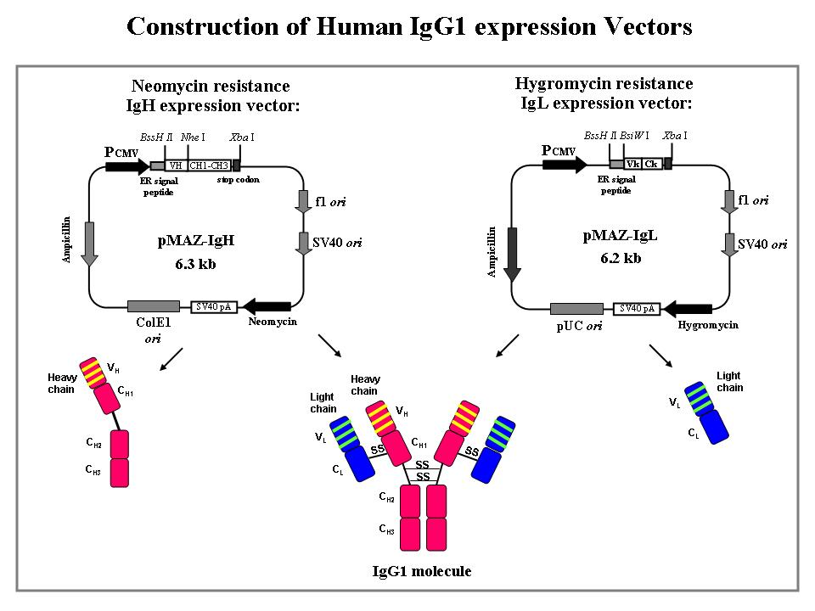
Targeted therapy encompasses a wide variety of different strategies, which can be divided into direct or indirect approaches. Direct approaches target tumor-associated antigens by monoclonal antibodies (mAbs) binding to the relevant antigens or by small molecule drugs that interfere with these proteins. Indirect approaches rely on tumor-associated antigens expressed on the cell surface with antibody–drug conjugates or antibody-based fusion proteins containing different kinds of effector molecules. To deliver a lethal cargo into tumor cells, the targeting antibodies should efficiently internalize into the cells. Similarly, to qualify as targets for such drugs newly-discovered cell-surface molecules should facilitate the internalization of antibodies that bind to them.
Internalization can be studied be several biochemical and microscopy approaches. An undisputed proof of internalization can be provided by the ability of an antibody to specifically deliver a drug into the target cells and kill it. Recently we presented a novel IgG binding toxin fusion, ZZ-PE38, in which the Fc-binding ZZ domain, derived from Streptococcal protein A, is linked to a truncated Pseudomonas exotoxin A (Figure 12). The preparation of complexes between ZZ-PE38 and IgGs that bind tumor cells and the specific cytotoxicity of such immunocomplexes was also reported. Our results suggest that ZZ-PE38 could prove to be an invaluable tool for the evaluation of the suitability potential of antibodies and their cognate cell-surface antigens to be targeted by immunotherapeutics based on armed antibodies that require internalization (Mazor 2007). The data from an anti-tumor experiment in a nude mouse tumor xenograft model (Figure 13) suggested that such molecules have an impressing anti tumor potential that should be further investigated.
Figure 12
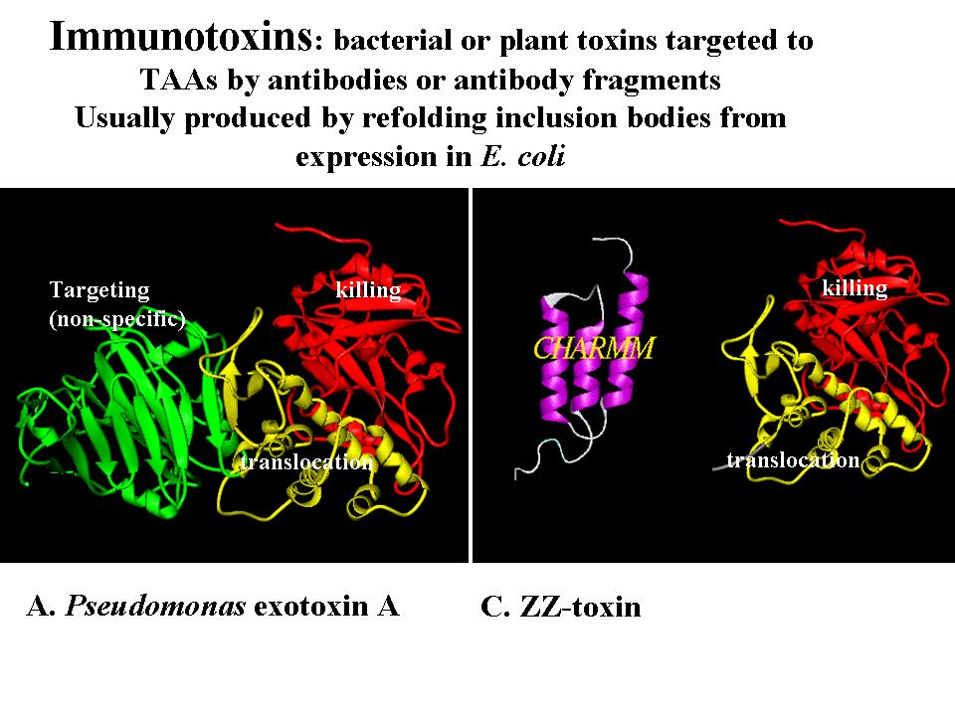
Figuer 13
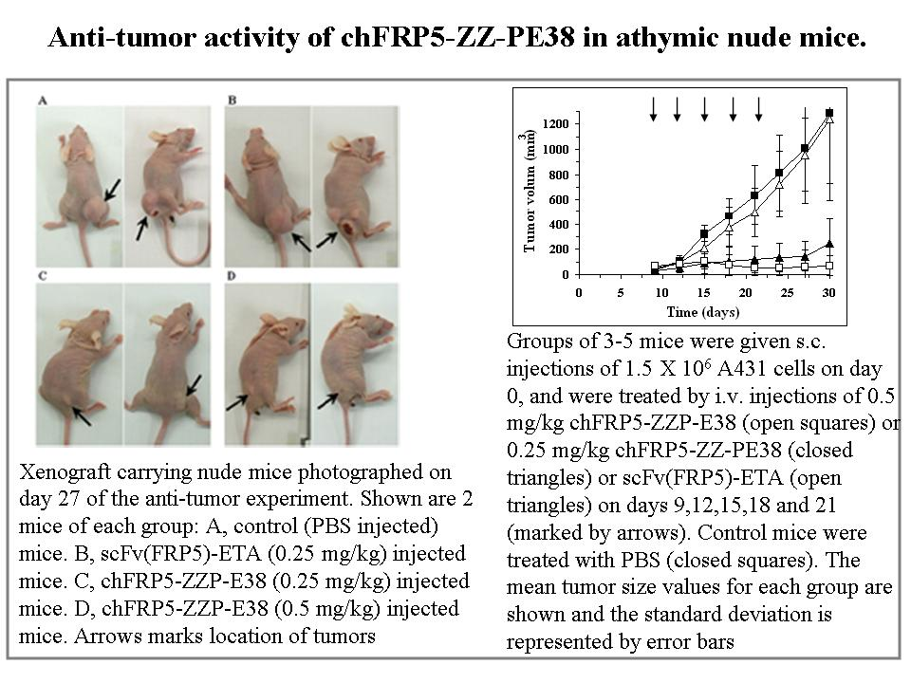
Targeted drug-carrying phage nanomedicines
While the resistance of bacteria to traditional antibiotics is a major public health concern, the use of extremely potent antibacterial agents is limited by their lack of selectivity. As in cancer therapy, antibacterial targeted therapy could provide an opportunity to reintroduce toxic substances to the antibacterial arsenal. A desirable targeted antibacterial agent should combine binding specificity, a large drug payload per binding event, and a programmed drug release mechanism.
Recently, we presented a novel application of filamentous bacteriophages (phages) as targeted drug carriers for the eradication of (pathogenic) bacteria. The phages are genetically modified to display a targeting moiety on their surface and are used to deliver a large payload of a cytotoxic drug to the target bacteria. The drug is linked to the phages by means of chemical conjugation through a labile linker subject to controlled release (Figure 14). In the conjugated state, the drug is in fact a prodrug devoid of cytotoxic activity and is activated following its dissociation from the phage at the target site in a temporally and spatially controlled manner.
Figure 14
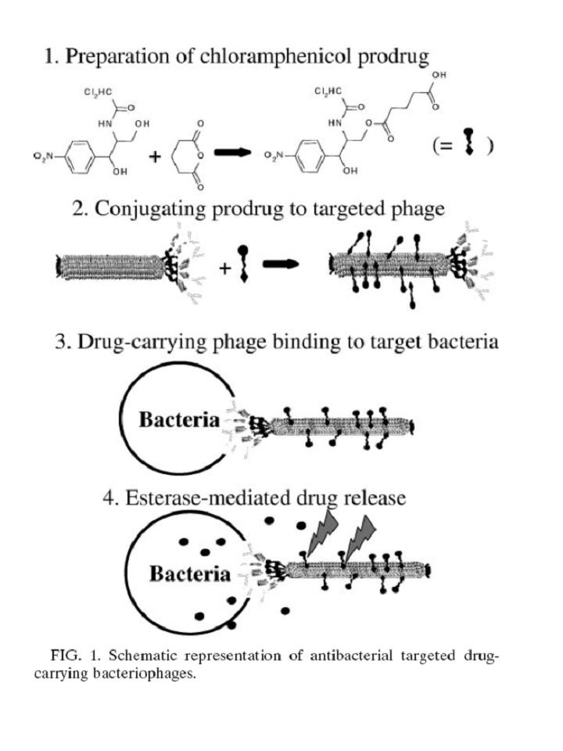
Our model target was Staphylococcus aureus, and the model drug was the antibiotic chloramphenicol. We demonstrated the potential of using filamentous phages as universal drug carriers for targetable cells involved in disease. Our approach replaces the selectivity of the drug itself with target selectivity borne by the targeting moiety, which may allow the reintroduction of nonspecific drugs that have thus far been excluded from antibacterial use (because of toxicity or low selectivity). Reintroduction of such drugs into the arsenal of useful tools may help to combat emerging bacterial antibiotic resistance (Yacoby 2006).
To overcome problems of limited solubility of the phages when loaded with a hydrophobic drug, such as chloramphenicol, we presented a novel drug conjugation chemistry which is based on connecting hydrophobic drugs to the phage via aminoglycoside antibiotics that serve as solubility-enhancing branched linkers (Figure 15). This new formulation allowed a significantly larger drug carrying capacity of the phages, resulting in a drastic improvement in their performance as targeted drug-carrying nanoparticles. As an example for a potential systemic use for potent agents that are limited for topical use, we present antibody-targeted phage nanoparticles that carry a large payload of the hemolytic antibiotic chloramphenicol connected through the aminoglycoside neomycin. We demonstrate complete growth inhibition toward the pathogens Staphylococcus aureus, Streptococcus pyogenes, and Escherichia coli (Figure 16) with an improvement in potency by a factor of 20,000 compared to the free drug (Yacoby 2007).
Figure 15
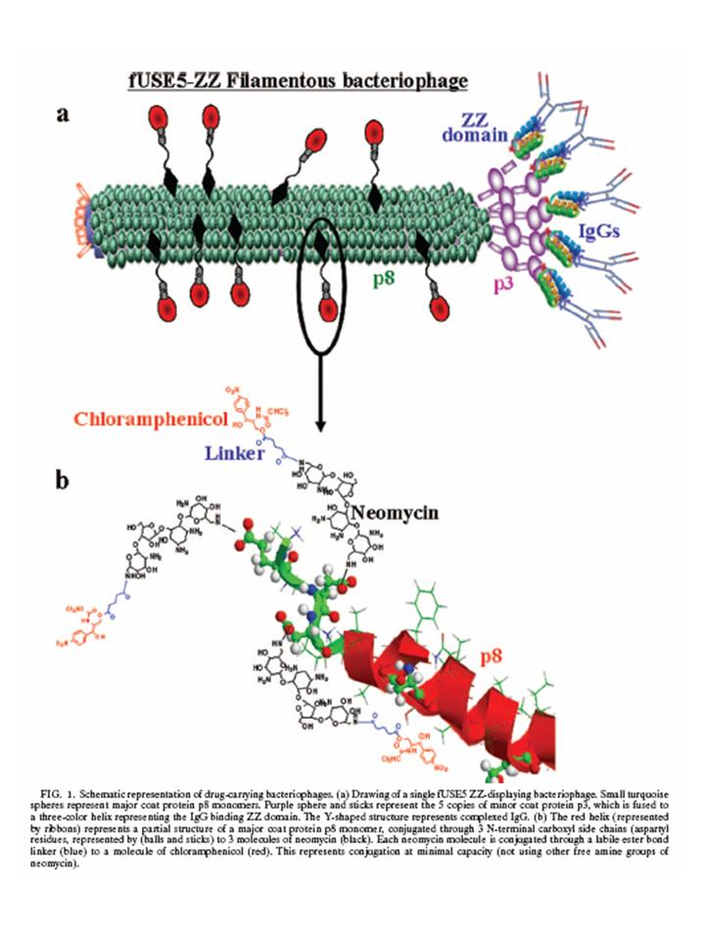
Figure 16
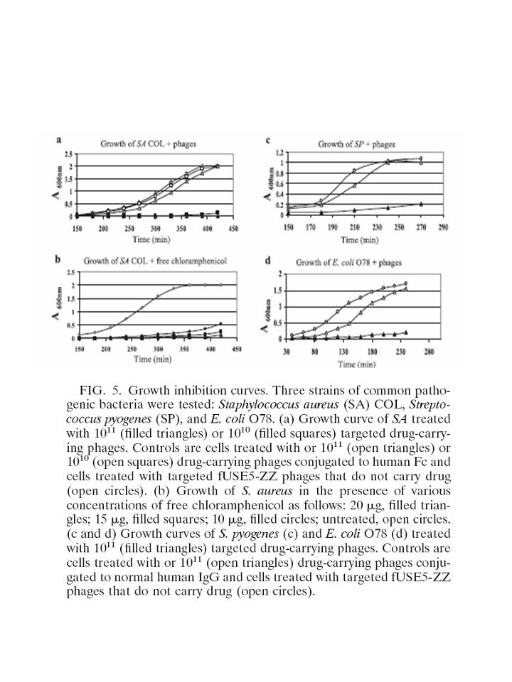
Hepatitis C virus
We are investing a lot of effort in studies of potential inhibitors of the Hepatitis C Virus (HCV) NS3 serine protease. HCV infection is a major worldwide health problem, causing chronic hepatitis, liver cirrhosis and primary liver cancer (Hepatocellular carcinoma). HCV encodes a precursor polyprotein that is enzymatically cleaved to release the individual viral proteins (Figure 17). The viral non-structural proteins are cleaved by the HCV NS3 serine protease (Figure 18). NS3 is regarded currently as a potential target for anti-viral drugs thus specific inhibitors of its enzymatic activity should be of importance.
Figure 17
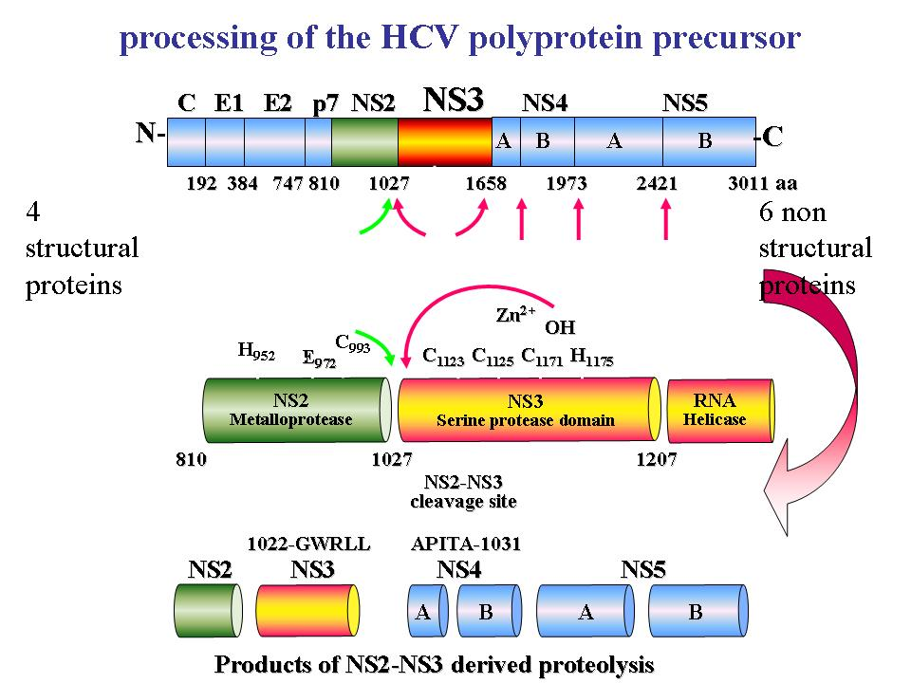
Figure 18
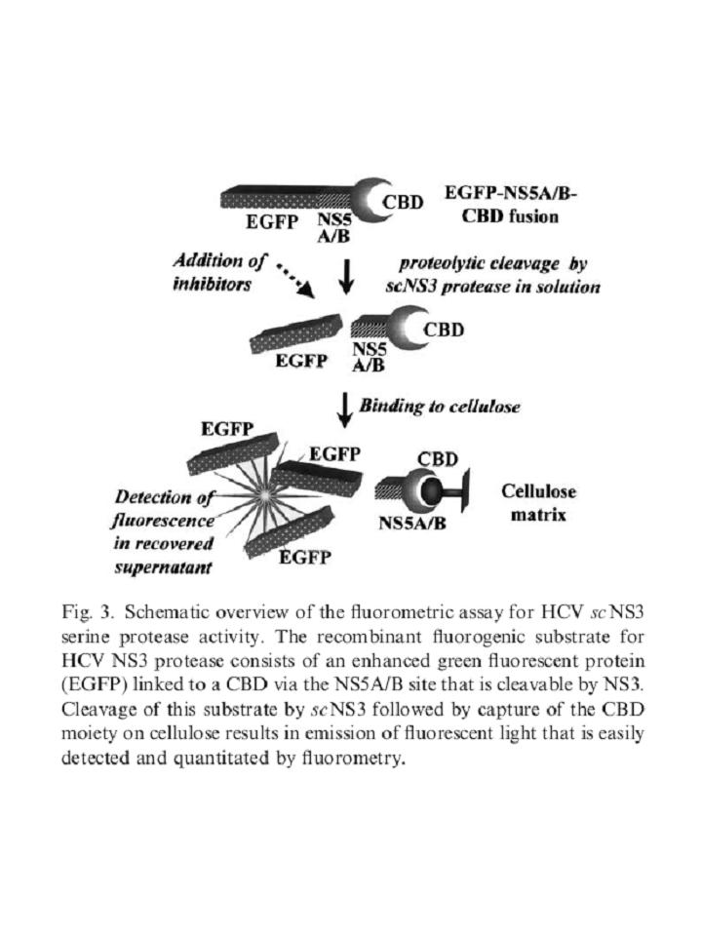
A prime requisite for detailed biochemical studies of the protease and its potential inhibitors is the availability of a rapid reliable in vitro assay of enzyme activity. We have developed a novel assay for measurement of HCV NS3 serine protease activity for screening of potential NS3 serine protease inhibitors. Recombinant NS3 serine protease was isolated and purified, and a fluorometric assay for NS3 proteolytic activity was developed. As an NS3 substrate we engineered a recombinant fusion protein where a green fluorescent protein is linked to a cellulose-binding domain via the NS5A/B site that is cleavable by NS3. Cleavage of this substrate by NS3 results in emission of fluorescent light that is easily detected and quantitated by fluorometry (Figure 19). Using our system we identified NS3 serine protease inhibitors from extracts obtained from natural Indian Siddha medicinal plants. Our unique fluorometric assay is very sensitive and has a high throughput capacity making it suitable for screening of potential NS3 serine protease inhibitors (Berdichevsky 2003).
Figure 19
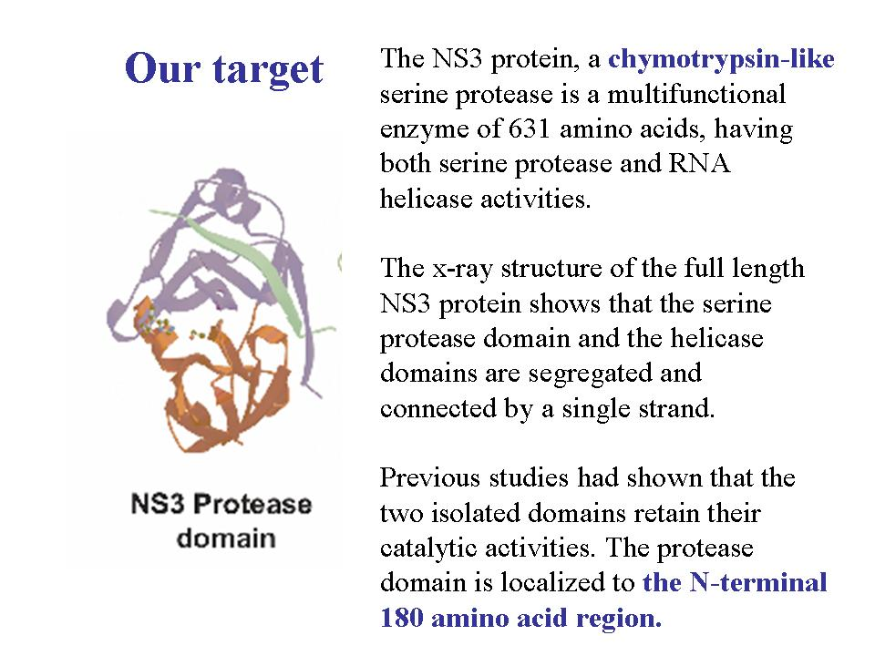
Using antibody phage display we turned to isolate single-chain antibodies (scFvs) that, as intracellular antibodies will inhibit NS3 within cells. A few year ago we reported that in addition to its role in the viral polyprotein-processing, the viral NS3 serine protease has been implicated in interactions with various cell constituents resulting in phenotypic changes including malignant transformation (Zemel 2001). NS3 is currently regarded a prime target for anti-viral drugs thus specific inhibitors of its activities should be of importance. With the aim of inhibiting NS3-mediated cell transformation we isolated and characterized eight anti-NS3 scFvs from a human synthetic scFv library. We investigated the phenotypic changes that NS3-expressing cells undergo upon intracellular expression of these antibodies in different subcellular compartments (intracellular immunization), assayed by their proliferation rate and their ability to grow anchorage independently. The intracellular location of NS3 and the scFvs were analyzed by immunofluorescent staining using confocal microscopy (Figure 20). We found that nuclear-targeted anti-NS3 intrabodies shuttled NS3 from the cytosol to the nucleus with concomitant inhibition of cell proliferation and loss of the transformed phenotype (Figure 21). We concluded that intracellular immunization-based gene therapy strategies may emerge as a promising antiviral approach to interfere with the life cycle and tumorigenicity of HCV (Zemel 2004).
Figure 20
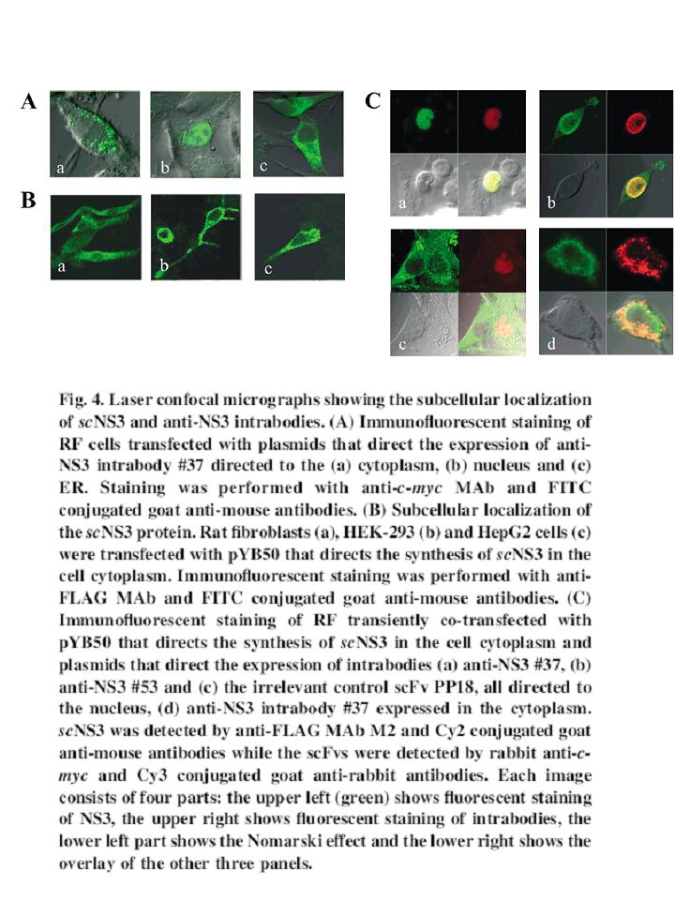
Figure 21
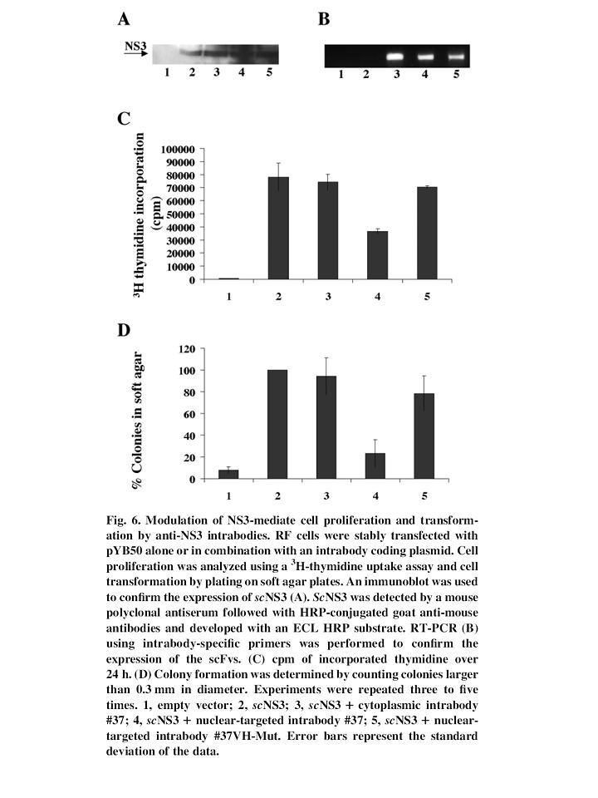
The antibodies we isolated in that study were inhibitors of NS3 serine protease activity. To isolated scFvs that are true inhibitors, we sorted to a different screening strategy.
We developed a novel genetic screen for inhibitors of NS3 catalysis applied it for the isolation of single-chain antibody-inhibitors. Our screen is based on the concerted co-expression
of a reporter gene, of recombinant NS3 and of stabilized scFvs in E. coli. The reporter system was constructed by inserting a peptide corresponding to the NS5A/B cleavage site of NS3 into a permissive site of the enzyme beta-galactosidase, with NS3 expressed from the same plasmid. The resultant beta-galactosidase enzyme was active, conferring a Lac+ phenotype that is lost upon induction of NS3 expression (Figure 22). The identification of inhibitors was demonstrated by isolating NS3 inhibiting single-chain antibodies, expressed from a compatible plasmid, was based on the appearance of blue colonies (NS3 inhibited) on the background of colorless colonies (NS3 active) on X-gal indicative plates. Our source of inhibitory scFvs was a library prepared from spleens of NS3-immunized mice and subjected to limited affinity selection. Once isolated, the inhibitors were validated as specific NS3 binders and as bone fide NS3 serine protease inhibitors in vitro as well (Gal-Tanamy 2005) (Figure 23).
Figure 22
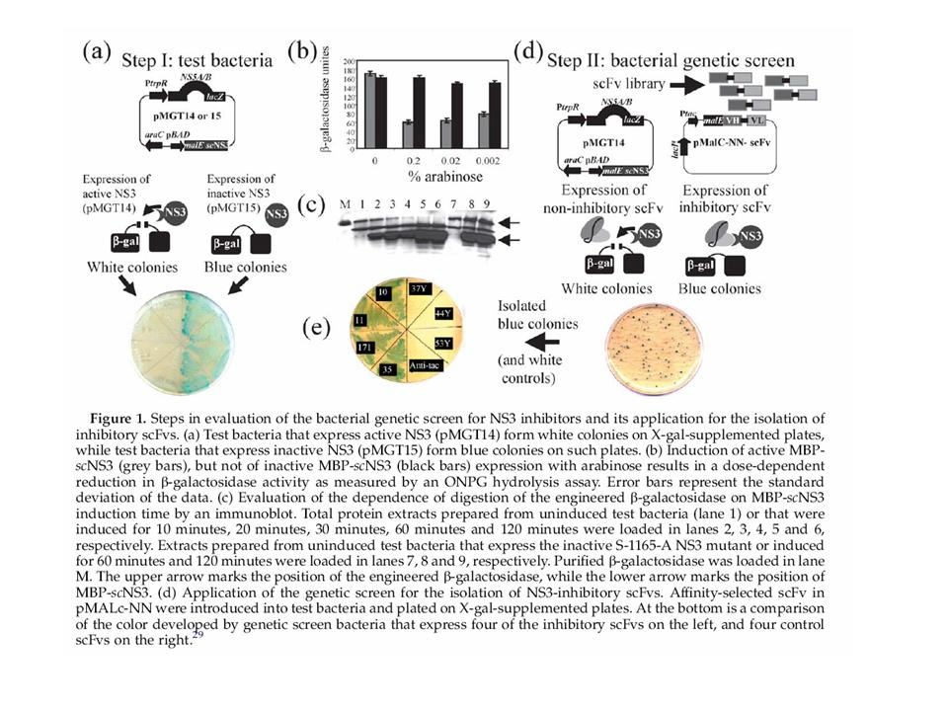
Figure 23
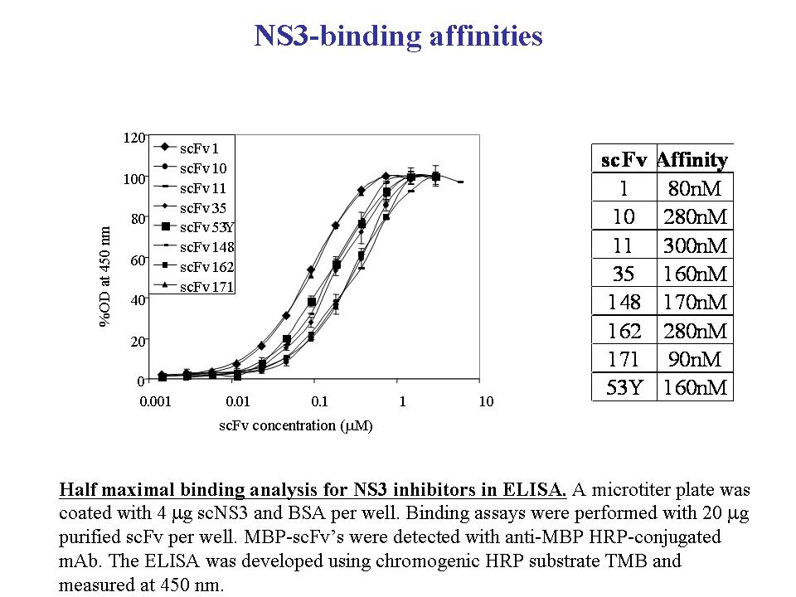
Our scFvs were further explored as potential intervention towards the eradication of HCV infection using advanced HCV RNA replicons. The potential of the NS3-neutralizing scFvs to suppress HCV RNA replication was evaluated using SEAP secreting replicon-bearing Huh7 cells. SEAP secretion was suppressed in replicon cells transiently transfected with NS3-neutralizing but not in a control cell line nor by control scFvs (Figure 24). This indicates that the effect is due to specific suppression of the HCV RNA replication by the NS3-neutralizing scFvs. These inhibitors suppress the replication of drug resistant mutants replicons as well, emphasizing their advantage over small molecule inhibitors. These Single-chain antibodies may emerge as useful clinical reagents as more specific and boadly administrated for the treatment of infectious diseases and cancer.
Figure 24
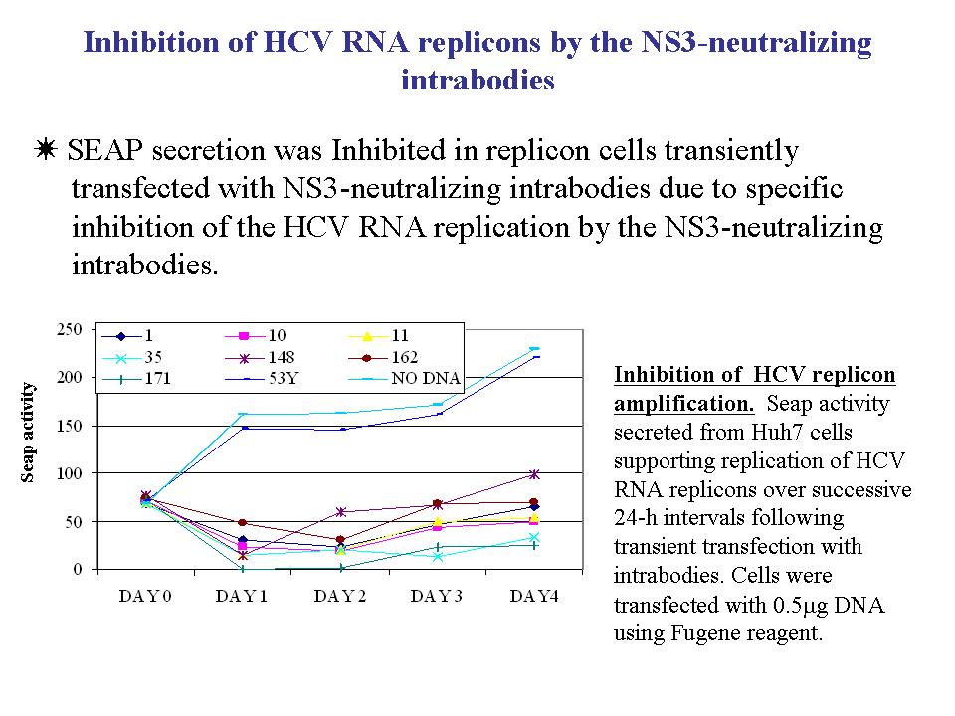
In addition to antibodies we turned to search for peptide aptamers as NS3 inhibitors. Peptide aptamers are short (in our case 8 amino-acid long) peptides that are stabilized by their presentation on a stable protein scaffold. We had initiated a study where a novel high-throughput in vivo genetic screen for NS3 catalysis and its inhibition was applied for inhibitors isolation. Here the screen was based on the concerted co-expression of a the reporter gene, recombinant NS3 and stabilized candidate molecules (MBP-scFvs and peptide aptamers) in E. coli. The peptide-aptamers were isolated from libraries where random sequences were inserted at the C-terminus of the E. coli MBP as linear peptides. Here too, the initial identification of inhibitory peptide aptamers was based on the their expression in bacteria that express the enzyme-substrate combination as well, by the appearance of blue colonies (NS3 inhibited) on the background of colorless colonies (NS3 active) on X-gal indicative plates. The peptide-aptamer inhibitors were validated as NS3 binders and as in vitro inhibitors of catalysis as well. We are currently evaluating the aptamers using the RNA replicons described above.

