Prof. Uri Gophna’s Research
Understanding evolutionary processes behind bacterial adaptation has contributed to both the medical community and to evolutionary theory. Broadly, our research interests revolve around two related topics: 1. The role of lateral gene transfer (LGT) in the evolution of microorganisms and 2. The study of host-microbe interactions, with particular focus on the human gut microbiome in health and disease. We are interested in fundamental questions in microbial ecology and evolution: What are the factors that drive or limit gene flow between prokaryotic species? How were the first eukaryotes formed? How does host specificity evolve? Which forces shape the population structure of microbial communities in the mammalian microbiota? Which microbial species can cause chronic diseases?
Microbial ecology in health and disease. The mammalian intestinal microbiota (formerly known as gut flora) is a complex ecosystem containing hundreds of microbial species, and bacterial cells in our body vastly outnumber our own cells. The microbiota not only contributes to the nutrition and gut development of the host but is also required for development of a healthy immune response, and is, to some degree, genetically determined. The human microbiota has been attracting tremendous interest and since there is increasing evidence supporting the involvement of the gut microbiota in several human diseases: from inflammatory bowel diseases, colorectal cancer and irritable bowel syndrome to metabolic syndrome and cardiovascular disease. However, due to its amazing complexity and the limitation of current microbe cultivation techniques, the microbiota remains a poorly understood ecosystem, in need of further research. We study the human microbiota using metagenomic techniques, and analyze samples from both healthy individuals and patients with gastric reflux disease, inflammatory bowel diseases and several types of cancer, to try and explore the different roles the microbiota plays in these diseases. We also characterize the changes in microbial bacterial communities that follow therapy, either pharmacological or surgical, and how they contribute to side effects of these treatments.
Impact of lateral gene transfer on microbial evolution. Lateral gene transfer plays a crucial role in the evolution of microorganisms, including bacterial pathogens, and is a major source of genetic innovation. Many known virulence factors are the product of such gene exchange, probably because the strong selective advantage they confer greatly increases the genes' chances of being fixed in a population. Using a variety of bioinformatic approaches we identify laterally transferred genes and study their evolution. We also investigate why some gene functions are transferred frequently while others are only rarely horizontally acquired. We are particularly interested in cases where such genes are the driving forces behind speciation processes in archaea and bacteria. We are also exploring inter-species recombination, a process which was believed to be extremely rare in prokaryotes, but is now known to exist in several prokaryotic groups. We have recently shown that inter-species hybrids can be formed by a natural cell fusion process in archaea and that up to 17% of the genome can be easily exchanged. The huge size of these recombined chromosome sections may explain the transfer of extremely complex adaptive traits, such as aerobic metabolism acquired by the methanogenic ancestor of extant halophilic archaea. Furthermore, the capacity of archaea for inter-cell fusion (Rosenshine, Tchelet, and Mevarech, Science 1989, see figure) may be at the heart of the bacterium-archaeon fusion event that possibly gave rise to the first eukeryotes. Since the fusion hypothesis of eukaryogenesis is still disputed by many, we are attempting to generate genetic evidence for its feasibility in the laboratory.
A schematic representation of the proposed mechanism for mating in halophilic archaea
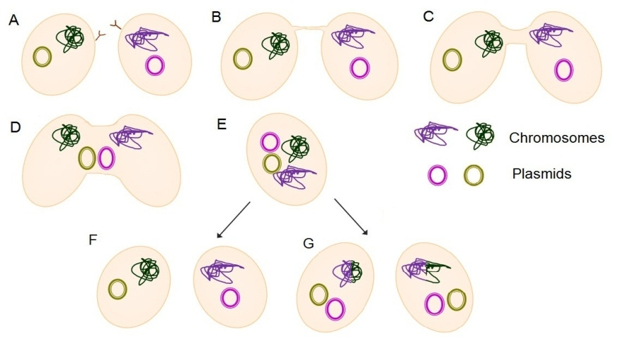
Amorphous lines represent the chromosome while the small circles represent plasmids A. Two cells are at close proximity. B.Cells establishing physical contact, through creation of cytoplasmic bridges. C+D. Expansion of the bridges and subsequent creation of fused cells. E. Hetro-diploid (heterozygous) cells, containing two different chromosome types and all plasmids combined. This state can lead to: F. Segregation of the chromosomes and plasmids that would result in reversion into the original state, or G. Recombination between the chromosomes that creates recombinants (or hybrids in the case of inter-species mating) with new genotypes. Independently of the fate of chromosomes, the plasmids can be exchanged or divided unequally.

